

TEAM THE GOLDFISHES

PROJECT FOR MATH GAMES



NOVEMBER/DECEMBER

2020

Table of Contents

1.Authors: 2

2.Summary: 2

2.1Goals 2

2.2Main stages of realization 3

2.3Diagram 3

3.Description of the functions used 4

# 1.Authors:

* **Karina Tangardzhieva**

-Scrum trainer

-[[KGTangardzhieva19@codingburgas.bg](mailto:KGTangardzhieva19@codingburgas.bg)](https://codingburgas.org/)

* **Petya Petkova**

- Front-end developer

-[PIPetkova19@codingburgas.bg](https://codingburgas.org/)

* **Polya Dimitrova**

-C++ developer

-[PDDimitrova19@codingburgas.bg](https://codingburgas.org/)

* **Lubomir Bozukov**

-Code checker

-[LVBozukov19@codingburgas.bg](https://codingburgas.org/)

# 2.Summary:

## 2.1Goals

The goal of our project is to create a game and when you play that game to have fun. We made tic tac toe between 2 players. I think the project is successful!

## 2.2Main stages of realization

First stage – **planning**. The first stage of the realization of our project was to create a meeting and discus the different roles and tasks that we had to do.

Second stage – **realization**. When the tasks and roles were clear, we started to work on them. We began writing the project code, making the site and making the presentation and documentation that explain it in more detail.

Third stage– **presentation**. The final stage is to submit in front of the judges the finished product.

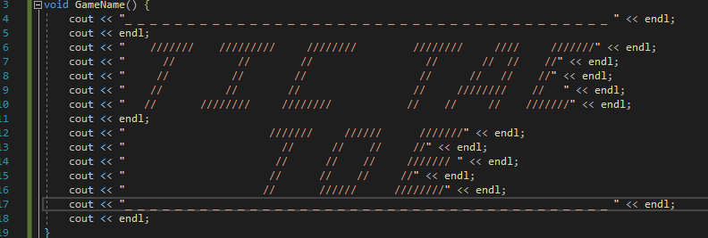

## 

## 2.3Diagram

# 3.Description of the functions used

|  |  |  |
| --- | --- | --- |
| Function name | Purpose | Returned value |
| GameName() | Function for starting the game | VOID |
| GameBoard() | Function for the board of tic tac toe | CHAR |
| GameBetween2Players() | Function for the game between 2 players | VOID |